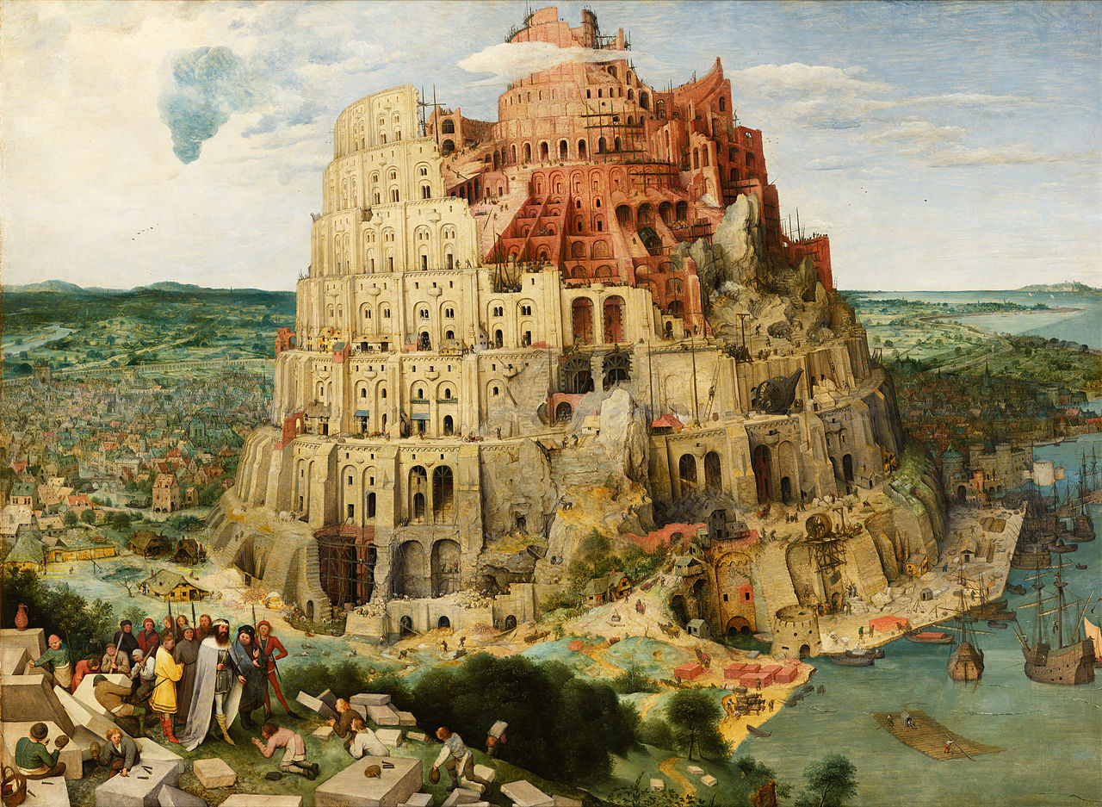**Metacasanova**

**A High-performance Meta-compiler for Domain-specific Languages**

Francesco Di Giacomo